

MGT628 People Analytics

**Final Assignment**

**Section 1**

Submitted to faculty: Prof. Siddhartha Saxena

Date of Submission: 22nd November, 2022

**Student Details**

|  |  |  |
| --- | --- | --- |
| Roll No. | Name of the Student | Name of the Program |
| AU1910010 | Prisha Thakkar | BBA (Hons) |

2022 (Monsoon Semester)

In this assignment, we had to choose a data source and create a dashboard for visually representing it using Power BI or Tableau with filters to get a better understanding of the data.

We have chosen Power BI to make the dashboard and add a dynamic mechanism to the data.

The data chosen for the project describes different projects and their attributes which are as follows:

1. **Title of the Project**
2. **Description**: Brief note about what the project intends to do.
3. **Type:** what category does the project belong to. Which namely are cost reduction, income generation, process improvement and working capital.
4. **Manager:** The person in charge of the project.
5. **Region:** Where the project is located.
6. **Department:** In which field will the project be used if completed.
7. **Cost:** How much does the final outcome including the testing, the project will cost.
8. **Benefit:** How much benefit will the project return back once it is completed.
9. **Complexity:** In terms of high, medium and low, what is the complexity of the project.
10. **Status:** In terms of In-progress, cancelled, completed and on-hold what is the current status of the project.
11. **Completion:** How much of the work is done to get the project to the completed status.
12. **Year:** Expected end year of the project.
13. **Month:** Expected end month of the project.
14. **Start Date:** The date when the project was started.
15. **End Date:** Expected completion date of the project.
16. **Phase:** In terms of,

1. Explore

2. Develop

3. Plan

4. Implement

5. Measure

Which phase is the project currently in.

## The Information about Sheets and relationships:

### Type Sheet:

The goal of this sheet is to define a relationship between the type of the project and how it affects other aspects of the project.

Other aspects of the project being, the making cost, the benefit and the complexity.

There are many types of project in the source data sheet, such as:

* Income Generation
* Process Improvement
* Working Capital Improvement
* Cost Reduction

The sheet defines the relationship between how each of these types influence the cost of the budget, which type of project costs more to make? and which type returns more benefit? Which type returns the most return?

We have also added complexity of the type of the project in the sheet, which can be used to analyse which type of project cost the least amount of investment, and return the highest of benefits with moderate or low amount of complexity.

### Managers Sheet:

The goal of this sheet is to define a clear relationship between the managers and the projects that they have worked on in the past and what kind of results they have provided.

The sheet has a one to many mapping of the manager to the projects. Meaning that one manager might’ve worked on more than one project and that is the precisely why this sheet exists.

We have used variables like Project cost and Project Benefit to know the efficiency of the manager in terms of financial management and another variable used is completion rate to know how much the manager can get done and in what amount of investment.

We have also added the complexity of the project into the sheet to know more about the complexity of previous or the current project that a manager is working on and how much can he/she deliver under the high complexity projects.

### Region Sheet:

The goal of this sheet is to define a clear relationship between where a project is located geographically and how it impacts other areas of the project and what can be the most suited area for which kind of projects.

We have added Project cost and Project Benefit to the sheet to know the more about which region does the project cost more and how much does the project rely on external resources is known by the type of the project which then, can be predicted as to how much does a particular kind of project cost in a given region?

We’ve also added completion rate and the status in the sheet to know how many projects are done and to what extent in a particular region.

### Department Sheet:

The goal of this sheet is to define a relationship between the department of a project and other aspects of the project and how they might influence other areas of the organisation.

We have added the Project Cost and the Project Benefit to the sheet to know which department will return the most benefit at the lowest of costs and other financial activities related to it.

We have also added complexity and the completion to the sheet to know which department demands the highest computation power and which department has the lowest amount of project completion rate. This both describes which department can get the most amount of project done with the least amount of computation.

With this sheet, we can know the project department that provides the best financial gain with the least computation power and the most chances of completing the project or getting the return, so to say.

### Cost Sheet:

The sheet defines everything that an organisation might need to analyse in terms of the cost of the project.

In the sheet, we’ve added the project cost and the project benefit to get the starting point of the cost associated with the project.

Then, there’s project type to know which category does the belong to and project manager to know who is leading the project. We’ve also added the region and the department associated with the project.

Therefore, this sheet can describe the relationship of project cost with aspects such as region, manager, type and department. And so it can provide solutions to the questions such as which manager can get a particular type of project done in the south region within the field of eCommerce.

### Completion Sheet:

This sheet defines the relationship between what get the project done or how much done and what other factors impact it.

We’ve added project type, region, project manager and department to the sheet to know where the project is, and who’s leading it and which category does it belong to.

We’ve also added the current status, completion rate and the phase of the project to know the current updates on the work produced by the team within a project.

With the variables provided by the data, the sheet can provide solutions to the question such as how much work has been produced by the project in the north region with a particular manager in the Sales department.

## The Dashboard:

We’ve created the dashboard in Power BI. And it has 2 pages. The first of which contains some metadata about the projects described in the source data and the second page contains the data with the filters and some other information about the data.

On the first page, at the top we’ve the data about the capital divide among the project types which are Cost Reduction, Income Generation, Process Improvement and Working Capital. Then on the left side we have the search bar which can sort through the projects given in the source data. And underneath the search bar we also have some checkboxes which are used to sort through only some of the project types of the given data.

On the lower right side we’ve 3 charts, one bar chart and other 2 pie charts. One pie chart shows Project Benefit distribution among the regions that the project can be situated at. The second pie chart shows the Project cost distribution among the regions. And the bar chart shows how many projects are currently in which phase.

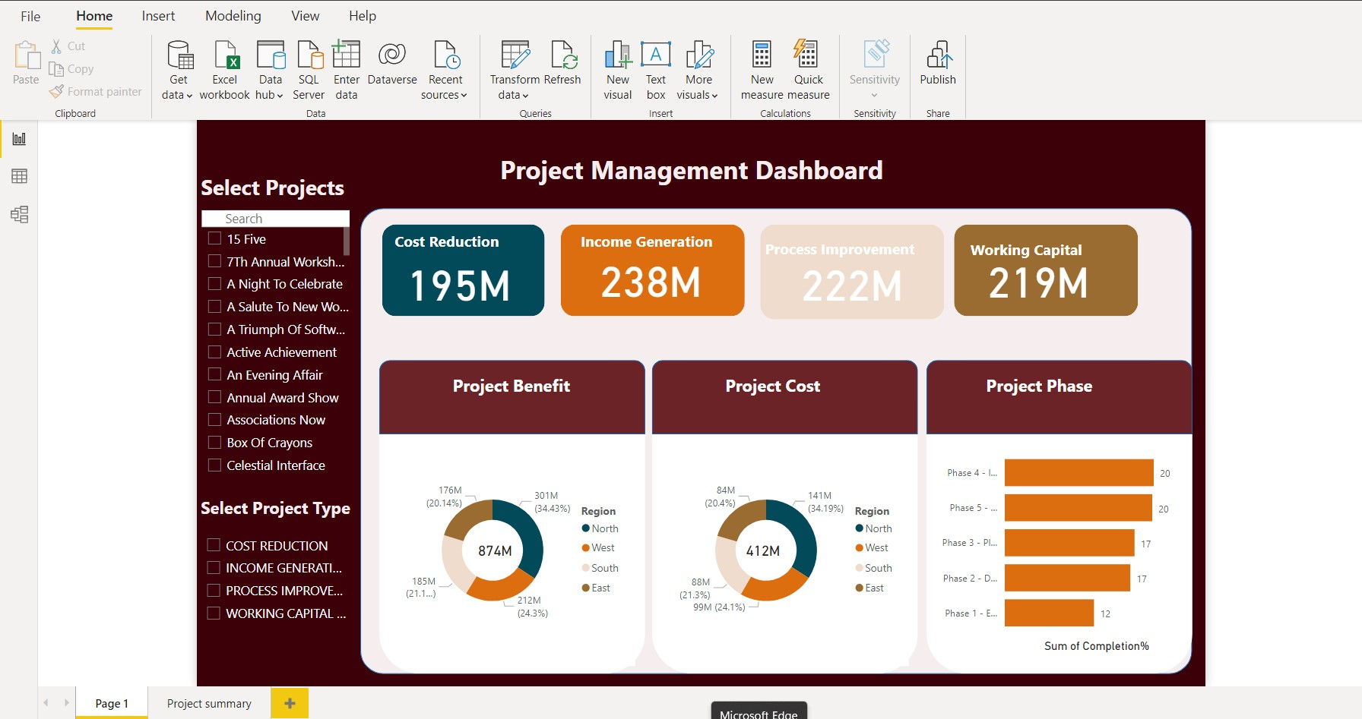

On the second page, We’ve the same information and the feature access as the first page but the main difference is in the data representation of the Project Summary and the Cost vs. Benefit bar chart on the lower right side.

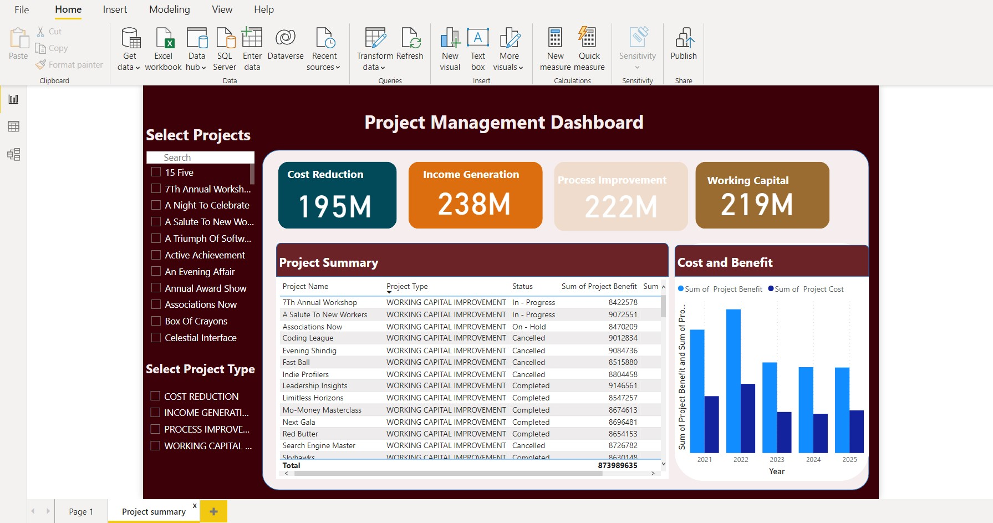

The Project Summary Table summarises the sample data of the source data and can be used to have a quick review of the overall data. The bar chart on the right hand side represents Sum of Project Cost and Project Benefit divided among the years from 2021-2025 so that the overall income of the organisation compared to other years can be easily predicted.

## Learning Outcomes and Problems Faced

One of the main problems faced by me was finding a suitable dataset, after finding multiple data and with trial and error i finalised on this dataset. After finding the data set and creating the sheets it was difficult to form the relationships. Creating the dashboard was both fun and difficult as changing the position of one element would change the entire layout. I chose Power Bi for this assignment because for me initially it was very easy and sir had explained the software in great detail and he had even taken a test which helped in increasing my confidence level in this software.